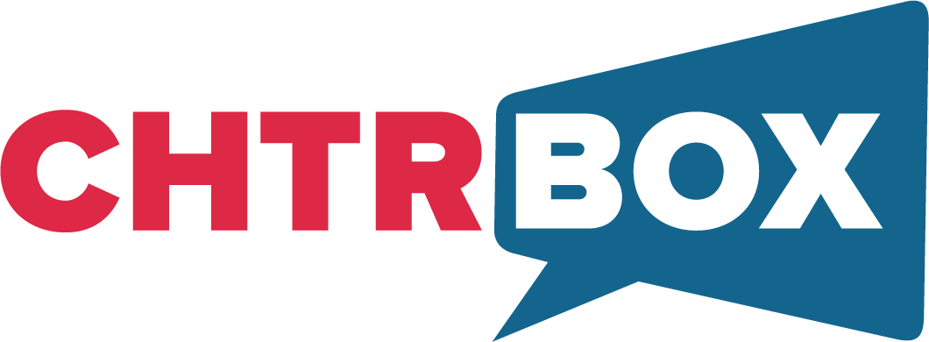
SOLUTIONS

- INFLUENCER MARKETING: Backed by data-driven creative strategy and end-to-end management, our primary offering drives successful campaigns that break through the clutter. ​​Our diverse network of 500,000+ leading and emerging content creators in India allows brands to reach their target audience with tailored, impactful campaigns that deliver real results. We’ve crafted successful campaigns for key accounts like P&G, HP, Amazon, CRED & more. Check out our Creds Deck here!

- CELEBRITY MARKETING: We connect brands with celebrities from Bollywood, OTT & sports that appeal to the masses while conveying brand messaging in a personalized fashion. We help identify the right persona that fits your brand objectives & manage the show end to end while delivering kickass content. We’ve enabled collaborations such as Varun Dhawan, Kiara Advani, Vijay Deverakonda & Samantha Prabhu for Samsung, Randeep Hooda, Apashakti Khurana for HP, Masaba Gupta for Lenovo, Ananya Pandey for Discovery, Pankaj Tripathi for Amazon & many more!
- CHTRBOX REPRESENT: At Chtrbox Represent, where we represent over 100 creators key categories like beauty, fashion, fitness, tech, food, dance, and more - whose clout reaches beyond social media. Our exclusive creators have done some impactful work and won awards such as Shantanu Dhope Cosmopolitan Beauty Influencer of the Year (Male) - Editors Choice. Ria Amin Beauty-Full Creator of the Year by POPxo Awards 2023. Akanksha Kommirelly won 25 Under 25 Telangana. A lot more were nominated for the Cosmopolitan awards - Deep Pathare Rahil Syed Samhita Sharma Bindiya Talluri!

- YOUTH:INK: As pioneers of student campus ambassador programs in India, we’ve done it all - peer referrals, youth sampling, brand advocacy, barter partnerships, content seeding, campus programs & activations – and we’re great at it. We believe that the best way to reach Gen-Z is to speak their language & on the platforms, they use – and who better to do this than Gen-Z influencers themselves!
Brands we’ve activated this for include: Converse, Vivo, Dell, The Souled Store, Bata, Whisper, Amazon miniTV, Herbal Essences amongst others!
- MICRO & NANO: Leverage our extensive network of micro and nano creators to onboard large volumes of high-quality content creators for your brand, across various genres such as Lifestyle, Entertainment, Travel, Young Working Professionals, Mom Community, Finance, Fitness, Infotainment, and more. We have a proven track record of successful campaigns with leading brands including Pinterest, CRED, Nykaa, Pampers, HK Vitals, Berrica, Streax Hair Colour, Instagram, Spotify, and many more.

- BHARATBOX: Our integrated offering across digital & social media, powering brands to reach India's regional consumers. We’re all about crossing borders to attract a regional audience by collaborating with the best influencers and content creators covering Tamil, Telugu, Kannada, Malayalam, Marathi, Bengali, Punjabi, and other regional languages. Key Brands here: Piramal Finance, ICICI Prudential, SBI Card, Nykaa, HK Vitals, Pampers, etc.

- SOCIAL MEDIA MANAGEMENT: Taking a consumer-1st & brand-2nd approach, under our division 'ChtrSocial' we help brands focus on content, and become influencers in their own right. We support or manage complete social media mandates to help grow the brand through creative and strategic storytelling & also focus on ROI driven campaigns through Performance Marketing!

- CONTENT PRODUCTION: Through ‘ChtrStudios’, we enable brands to create premium snackable content with influencers and creators, at scale. This content is further leveraged to push through digital media to meet brand objectives. We’ve created impactful content for key campaigns such as Amazon Alexa Originals, Amazon Alexa Anniversary & more!
- GLOBAL INFLUENCER MARKETING: Termed 'ChtrInternational', we help launch international brands in India and help Indian influencers gain opportunities in International markets. Outside of being empowered through our acquisition by QYou Media, a US based influencer marketing powerhouse, we have also joined forces with the largest influencer marketing companies across North America, Europe & Latin America to bring you INFLUENCE+UNITED, a first-of-its-kind global influencer marketing alliance. By being the exclusive Indian partner in the alliance, we enable both Indian & international brands to enter new markets by collaborating with the best creators from across the globe.
- INFLUENCER GIFTING: Through 'Funbox' - our influencer gifting solution for macro, micro, and nano influencers - enables brands to get their newly launched products out to influencers in their category for sampling, relationship building, and barter deals. Brands we’ve activated this for include Olay & HK Vitals.
- AR FILTERS: We help brands further amplify their campaign & communication across social media by creating custom AR Filters that help drive campaign messaging in an engaging & impactful manner. Proven to be 4x more engaging than other forms of content - we’ve curated these for brands like Whisper, Raskik & more. View our fun AR filters here!
We'd love to add value to your upcoming campaigns & requirements! Should you be interested please feel free to reach out to Mrunali Dedhia - 9699913129 or Karan Pherwani - 9833456280.

